**Jayraj Menon**

**2021300075**

**Batch B**

**ADV Exp 9 and 10**

**Description of dataset used for expt 9 \***

Country/Region: The geographical area of the data.

Year: The year of the recorded data.

Gender Participation Rate: The percentage of women participating in various sectors (e.g., workforce, education, politics).

Sector: The sector in which gender participation is measured (e.g., Workforce, Education, Politics).

Women in Leadership Positions: The number of women in leadership roles within organizations or governments.

Total Population: The total population of the region.

**Description of dataset used for expt 10 \***

Country/Region: The geographical area of the data.

Year: The year of the recorded data.

Enrollment Rate (%): The percentage of students enrolled in educational institutions.

Average Academic Performance: Average scores or grades of students.

Funding per Student (USD): The amount of funding allocated per student.

Demographic Group: The demographic group (e.g., Age, Gender, Ethnicity).

Total Students: The total number of students enrolled.

**Link of dataset used in Expt 9 \***

https://drive.google.com/file/d/1YSH8977IM2s6MtdUwbF792v-jbNTCAk7/view?usp=sharing

**Link of dataset used in Expt 10 \***

https://drive.google.com/file/d/1mfcAmu2GViFVjsuGyUE0YgXAujdpfsO0/view?usp=sharing

Visualizations:

Expt 9

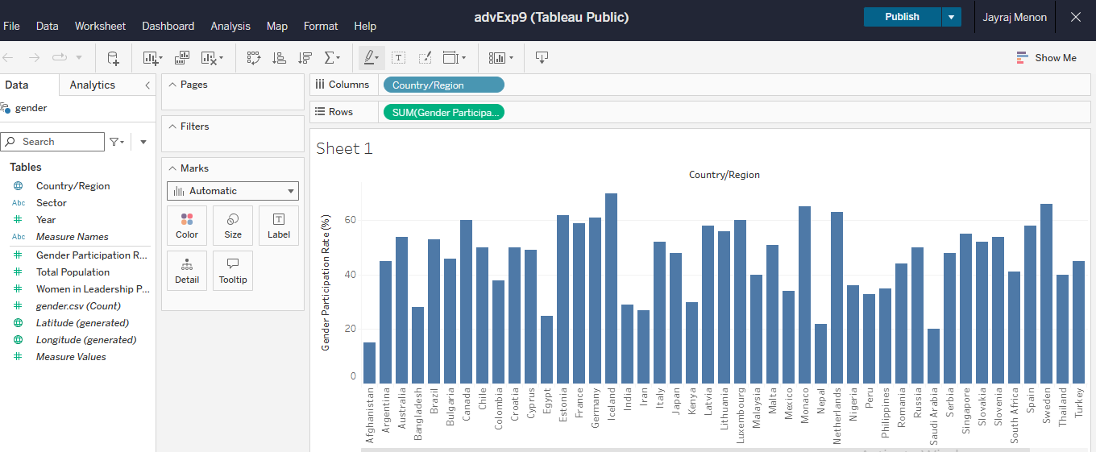

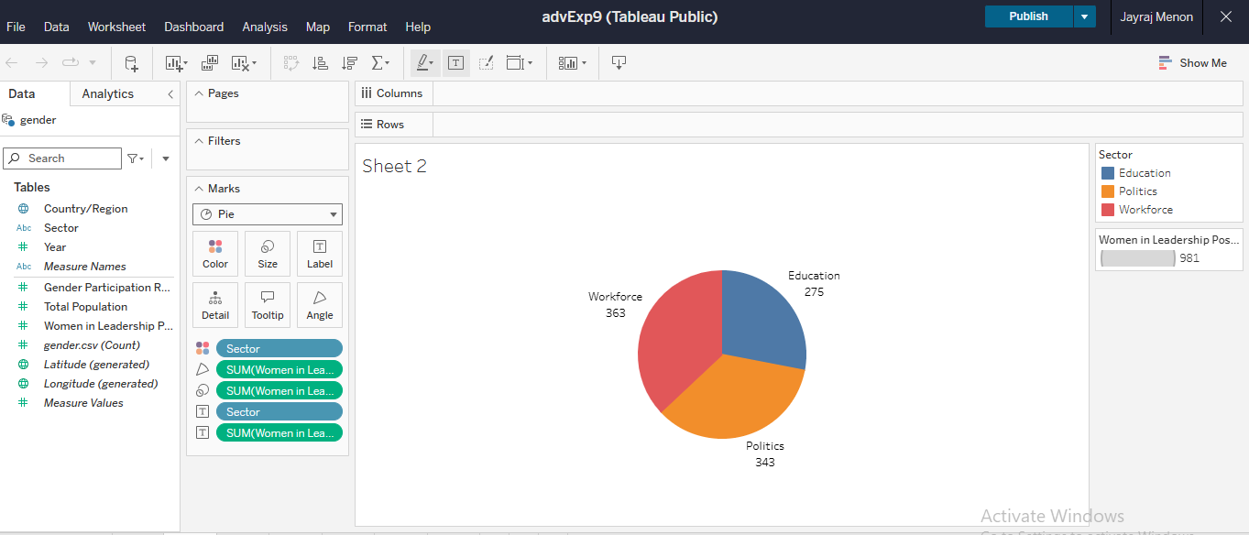

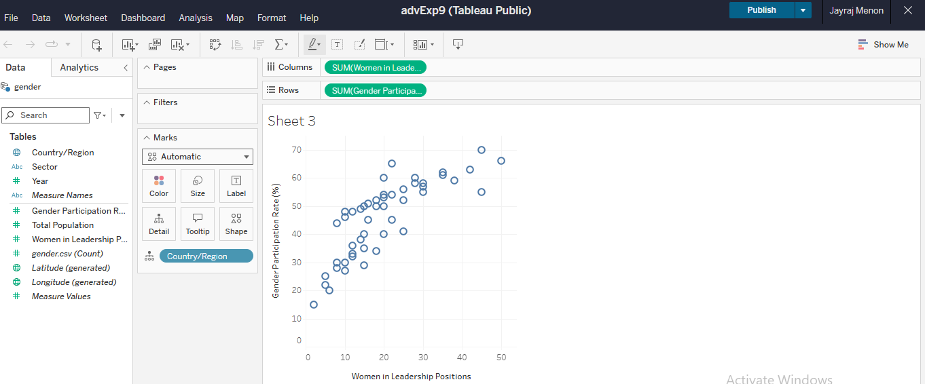

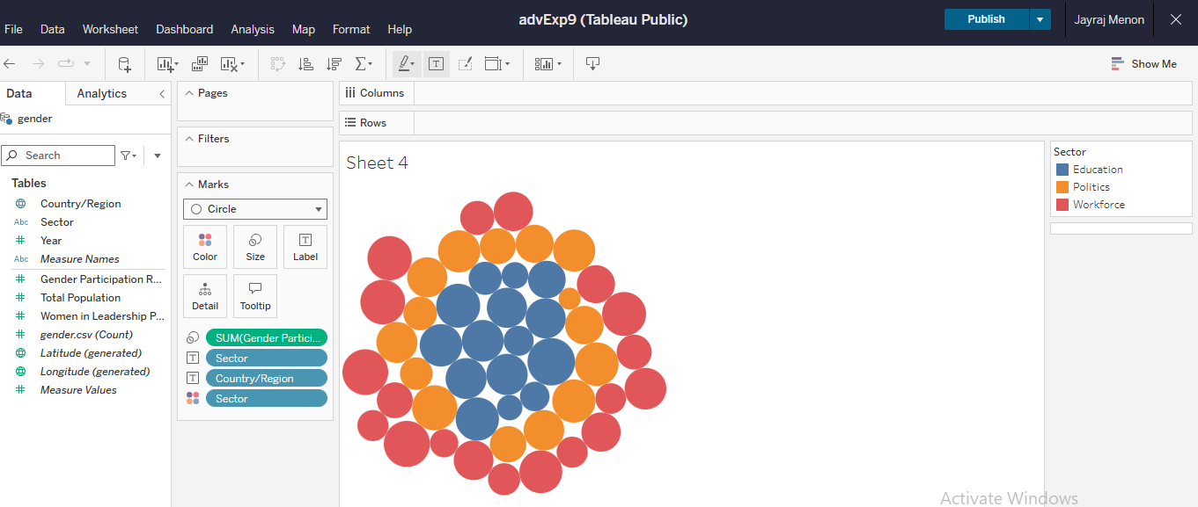

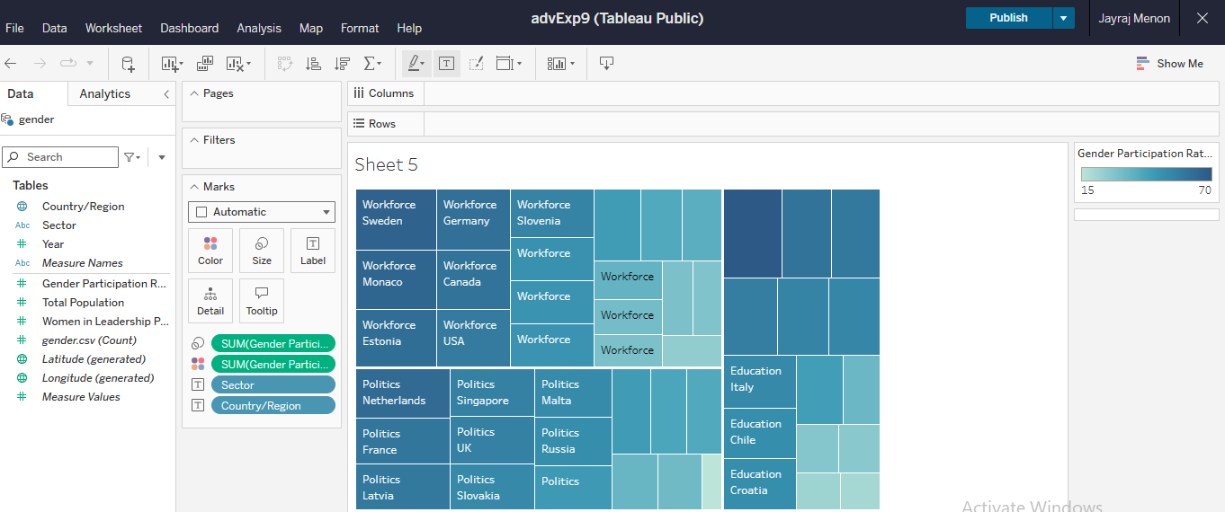

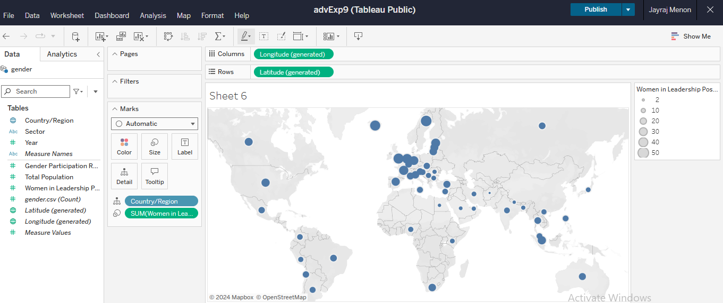

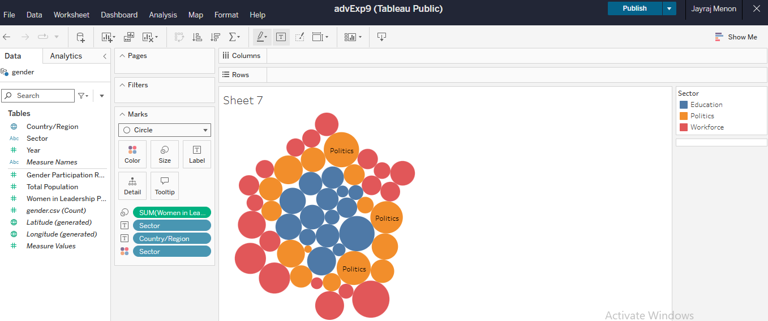

Visualizations:

Expt 10

